Questionnaire for Software Tester/QA

Objective:
- To assess the candidate’s level of technical competency in the areas of databases, business intelligence and testing.
- To better understand how an applicant processes and solves problems, such as design, implementation and attention to detail.
***Note: This test must be written by the candidate that is applying for a position. How we judge this test is based on the job being applied for. All candidates that meet or exceed our criteria for this test are then invited for an interview to give us a more detailed understanding of the candidate’s skill sets and personality.
Contents:
This questionnaire consists of 3 parts:
Part I: Basic SQL Exercise
Part II: Programming Exercise – please ZIP all the files that we need to run the program that you have written
Part III: QA Exercise
Deadline:
Please submit your answer by the timeline assigned through the email received.
Thank you for your time and effort. Good luck!

Part I: The questions below are designed to test your knowledge of SQL databases.
Below are some data tables:
Products table  ProductID Name UnitPrice  1 Chart 999  2 Gauge 599  3 Map 599 | SalesPersons table  PersonID Name City  101 Andy Toronto  102 Bob Montreal  103 Mathew Vancouver
Customers table
CustomerID | Company | City
10089 | IBM | Toronto
24535 | Johnsons | Toronto
33555 | Goodies | Montreal

Orders table
OrderID | CustomerID | PersonID | ProductID | Quantity | Discount
1 | 75353 | 103 | 2 | 5
2 | 24535 | 102 | 1 | 20 | 5%
3 | 10089 | 101 | 3 | 3
4 | 10089 | 101 | 1 | 55 | 20%
5 | 33555 | 101 | 1 | 2

QI-1: Identify the relationships between each table if you think it is applicable. You can modify the table if you think it is necessary.
QI-2: Based on the relationships defined in QI-1, write a SQL query that shows the total sales amount by each sales person for each product.
QI-3: Based on the relationships defined in QI-1, write a SQL query that shows all of the products ordered by IBM, including the number of units and total sales amount.

Part II: Programming Exercise
For HTML / JavaScript
This test, which consists of writing a simple utility application using HTML, CSS and JavaScript, is a standard test given to all technical applicants. How we judge this test is based on the job being applied for.
The results of this test will allow us to better understand your thought process when writing an application, such as design, implementation, usability, as well as your attention to detail.
Overview
The purpose of the utility application is to allow end-users to quickly enter and manage a list of name/value pairs.
Although this test must be written without help from any other person, you may use any standard reference material that is used during a normal programming cycle (such as online help or books). No third party class libraries or code snippets may be used, except for jQuery.
Create an HTML application using a UI similar to the one shown below. The application code should be written in HTML and JavaScript.
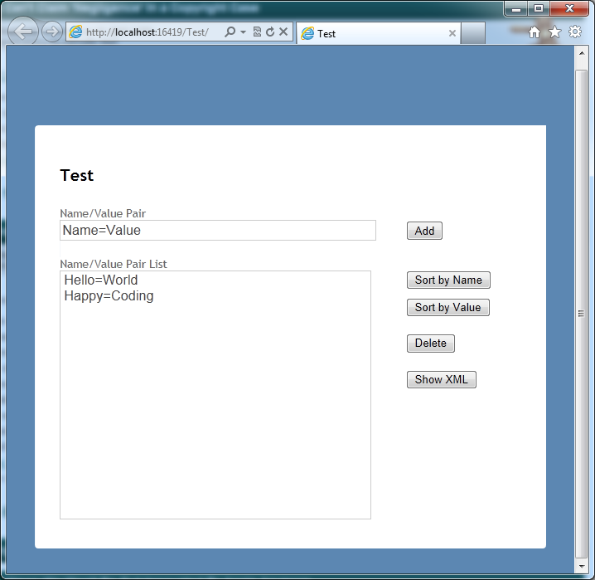

In addition, the UI should adjust based on what screen size is viewing it. For example, if viewed on a mobile phone (i.e. iPhone), the page should automatically adjust to present the layout in a better way. This also applies to re-sizing the browser on desktop, and viewing the page on a tablet.
Required Features:
Name/Value pairs are to be entered into the upper textbox. This textbox will be used by the end-user to quickly add Name/Value pairs to the list below.

Part III – QA Testing
Please write a test plan detailing the test cases that are required to thoroughly verify the correctness of the application above. Additional notes to be considered: this application is a web-based app and needs to support thousands of users
We are not going to provide any template for your test plan – be creative and create one that is easy to understand and follow by other testers. Feel free to use any material at your disposal to help you structure and categorize your test plan.
There are no limitations on the number of test cases you need to write in the document. However, you will need to strike a balance between the time required to run your test cases and the thoroughness of your plan – an excessive amount of test cases would yield a very high coverage of every possible outcome, but it could take too much time to go through all of them when being implemented.

